Combining advanced text-mining algorithms with mass spectrometry fragmentation data for substructure exploration in untargeted metabolomics data

**Justin J.J. van der Hooft1*, Joe Wandy2, Michael P. Barrett1, Karl E.V. Burgess1, Simon Rogers1,2\***

1 Glasgow Polyomics, University of Glasgow, Glasgow, United Kingdom

2 School of Computing Science, University of Glasgow, Glasgow, United Kingdom

**\*Correspondence:** Justin J.J. van der Hooft, Glasgow Polyomics, Level 2, Room 235, Wolfson Wohl Cancer Research Centre, Garscube Estate, Glasgow, G61 1HQ, United Kingdom.

justin.vanderhooft@glasgow.ac.uk

**\*Correspondence:** Simon Rogers, Room S123, School of Computing Science, Sir Alwyn Williams Building, Glasgow, G12 8QQ, United Kingdom.

Simon.Rogers@glasgow.ac.uk

Keywords: data mining, metabolomics, mass spectrometry, high-resolution, fragmentation, Latent Dirichlet Allocation (LDA), visualization, software, substructures, text-mining, pattern recognition.

**Abstract**

The potential of untargeted metabolomics studies to answer important questions across the life sciences is hindered due to the lack of computational tools that enable extraction of key biochemically relevant information. Available computational tools focus on using fragmentation spectra to identify molecules whose behavior suggests they are relevant to the system under study. Unfortunately, fragmentation spectra cannot currently identify molecules in isolation, but require authentic standards or fragmentation databases of known metabolites. However, fragmentation spectra are replete with information pertaining to the biochemical processes occurring within the system under study, much of which is currently neglected due to the paucity of standards, or database entries against which to compare. Here we propose an analytical workflow that exploits all fragmentation data from a given experiment to extract biochemically-relevant features in an un-supervised manner (i.e. without large volumes of training data). Intriguingly, we demonstrate that an algorithm originally utilized in text-mining, Latent Dirichlet Allocation, can be adapted to handle metabolomics datasets. Our approach extracts biochemically-relevant molecular substructures (‘Mass2Motifs’) from a collection of fragmentation spectra as sets of co-occurring molecular fragments and neutral losses. The analysis allows us to explore the biochemistry present in any given sample through a small number of annotatable molecular substructures, whose presence allows molecules to be grouped in a meaningful way regardless of classical spectral similarity. The presence of annotated substructures within a spectrum can support putative *de novo* structural annotation of molecules. Where MS1 fold change information is present (from e.g. a case v control study), peaks grouped according to shared substructures can be assessed for differential expression, suggesting biochemical explanations for the observed intensity changes.

**1.0 Introduction**

A field of research where large datasets are increasingly available is metabolomics, which pertains to study the entire small molecule composition of biological systems, most commonly using mass spectrometry (MS). Analysis of MS metabolomics data is challenging as many molecules cannot be identified from their mass alone (e.g. isobaric molecules, and isomers). Although separation by chromatography (e.g. LC-MS) can add additional discriminatory information, it does not solve the identification problem – it is frequently the case that isomers exhibit similar chromatographic behaviour, and chromatographic retention time is notoriously unpredictable and non-reproducible. Put simply, metabolite identification by full scan (MS1) mass spectrometry is very difficult for some molecules and impossible for others [1, 2].

An effective route to partially ameliorate this problem uses the fact that fragmentation spectra incorporate considerable information regarding structural identification. Tools have been developed to assist in spectral analysis of fragmentation data [3-5]. Most are based on comparing individual fragmentation spectra to reference spectra [4, 6] stored in public databases, e.g. MassBank [7] or HMDB [8], and are thus constrained by the relatively limited number of reference spectra that are available, or are predictable (using either known biochemical rules [9, 10] or theoretical fragmentation spectra of known structures [11]). This is particularly limiting when analysing exotic organisms or, for example, when investigating the effect of a novel therapeutic.

Despite the focus on it, metabolite identification is rarely the end-goal in an untargeted metabolomics analysis. Rather, it is a route to understanding the biochemistry (and changes in biochemistry) within the system under study. For example, identified molecules are mapped to pathways whose relative activity can be estimated from fold changes of the individual molecules. Poor identification coverage will result in poor biochemical insight. In this paper, we propose a method that collectively analyses all fragmentation spectra in a particular dataset to expose the biochemistry without relying on metabolite identification. Our inspiration comes from machine learning techniques for text processing and analysis [12]. This is a field in which sophisticated computational analysis of complex datasets is very mature and one that we believe has much to offer to the metabolomics community.

Pooling information from all full scan and MS2 spectra in a dataset is likely to offer insight not available when considering spectra individually. The lack of techniques that do this can be explained by the complexity of the resulting data [13]. Recently released tools that do use all acquired MS2 spectra include “molecular networking” [14-16] and “MS2Analyzer” [17][1, 10, 11]. Molecular networking clusters MS1 peaks based on their MS2 spectral similarity to produce networks. The presence of an identifiable metabolite in a cluster allows putative structural identification of its neighbours [14] – clear evidence that sharing information across spectra is beneficial. However, extracting the spectral features causing the clustering must be done manually and MS1 peaks can only be clustered if they share high overall spectral similarity. Although two molecules sharing many common fragments are likely to be functionally similar, there are many cases where chemical similarity is due to a shared substructure/moiety (e.g., histidine, ferulic acid, or tyramine) only accounting for a small portion of the spectra. Molecules sharing a substructure but differing elsewhere will often not have a high degree of spectral similarity and will not be clustered.

MS2Analyzer mines high-resolution fragmentation MS2 spectra for specific mass fragments, neutral losses, and m/z differences [17], i.e., it requires prior knowledge of relevant combinations of fragments or losses. Whilst some fragments and losses are likely to be common to many experiments (e.g. CO or H2O losses), in untargeted metabolomics experiments, sample-specific mass fragments are easily overlooked. MS2Analyzer and Molecular Networking can be positioned at opposite ends of a data analysis spectrum: Molecular Networking requires no user intervention but will potentially fail to group molecules that share only small substructures whilst MS2Analyzer can find all molecules that do share a particular set of mass fragments (or neutral losses) but these must be provided by the user. Our proposed approach falls between these two – it is able to find relevant substructures based on the co-occurrence of mass fragments and neutral losses in the data, and group the molecules accordingly.

Machine learning and Bayesian statistical approaches are being increasingly applied to metabolomics problems such as retention time alignment and prediction, feature detection and annotation, and ranking of identification candidates [5, 11, 18-22]. Our approach is based on Latent Dirichlet Allocation (LDA) [12], a probabilistic topic model. LDA has been used in genomics [23], metagenomics [24], and mRNA expression data analysis [25, 26], but never before to exploit the parallels between MS2 fragmentation data and text analysis.

Fragmentation spectra contain recurring patterns of fragments and losses due to the presence of common biological substructures (e.g. a hexose unit, or a CO loss). Here, each observed spectrum is assumed to be comprised of one or more of these substructures. The representation of small molecules as combinations of building blocks has previously been used for the annotation of a small number of molecules in direct infusion-MS with fragmentation [27] and for metabolite classification in GC-MS [28, 29]. CSI:FingerID ranks candidate molecules based on the presence and absence of various predefined structural features, including substructures [5]. These studies reveal the potential of substructure-based approaches in MS but require structurally known training data, which is costly to produce and often platform-specific. Our proposed method is applicable to any platform and requires no training data.

Figure 1 demonstrates the parallels between text and MS fragmentation data that motivates our approach. We term LDA applied to fragmentation data ‘MS2LDA’. As LDA decomposes documents into topics based on frequently co-occurring words, so MS2LDA decomposes fragmentation spectra into their constituent building blocks of frequently co-occurring fragments and neutral losses (referred to as ‘Mass2Motifs’). Crucially, MS2LDA achieves this with a purely data-driven approach. By using all of the fragmentation spectra generated by data-dependent mass fragmentation analysis (DDA), it learns the conserved substructures (the Mass2Motifs) and the decomposition of the fragmentation spectra (into Mass2Motifs).

In this paper we describe an analysis pipeline that performs the necessary data pre-processing, extracts Mass2Motifs and allows the user to explore the results in an interactive visualization environment. We demonstrate MS2LDA by analysing four beer extracts. We show that without labelled training data or metabolite identification, MS2LDA is able to find mass patterns indicative of easily identifiable biological substructures, some of which are pathway related. The presence of one or more of these annotated Mass2Motifs in a particular spectrum can aid in the putative *de novo* annotation or functional classification of otherwise unidentifiable molecules. Many more molecules can be annotated in this way than can be identified by comparison with reference spectra. This is particularly useful for hypothesis-generating research. For example, if a group of molecules with similar changes in MS1 abundances (from comparison across a range of perturbation conditions) share an identifiable pathway-related substructure, we can immediately generate a hypothesis as to the source of their change in abundance, regardless of whether or not these molecules can be identified via traditional techniques – we are able to bypass the traditional identification bottleneck. The ability to use information from the spectra of molecules that cannot be identified allows us to extract greater insight from these rich data sets.

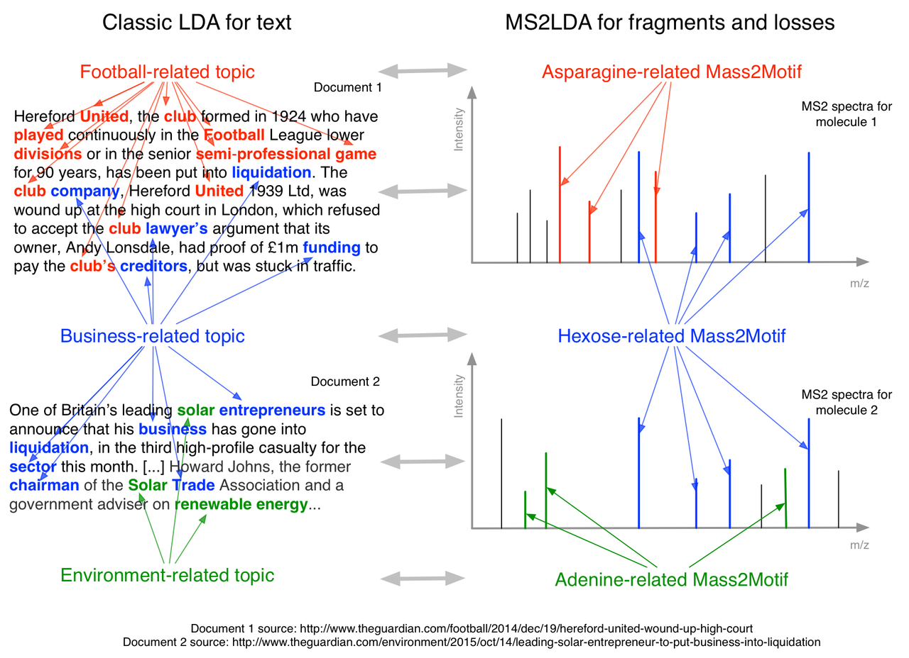

Figure 1: Analogy between LDA for text-mining and MS2LDA. In this example, we can see that traditional LDA has extracted topics that can be interpreted as ‘football related’, ‘business-related’ and ‘environment related’. Each document is a combination of different topics. In a similar manner, MS2LDA extracts different sets of concurring mass fragments or losses (Mass2Motifs) from the fragmentation spectra of precursor ions that can be interpreted as ‘Asparagine-related’, ‘Hexose-related’ and ‘Adenine-related’. Each fragmentation spectra is made up of one or more Mass2Motifs.

**2.0 Material and Methods**

## 2.1 Materials

### 2.1.1 Beer samples

We used beer samples as representative of complex mixtures of diverse biochemically relevant compound classes like amino acids, nucleotides, and sugars. Beer extracts were acquired from three different commercially available beers and one home-brewed beer: *Beer1* is sampled from a home-brewed bottle of German Wheat Beer of which the Beer sheet is available (see section 1 in the Supporting Information); *Beer2* is sampled from a bottle of ‘Jaw Glyde Ale’ (a Golden/Blond Ale) brewed by JAW Brew (http://www.jawbrew.co.uk); *Beer3* is sampled from a bottle of ‘Seven Giraffes Extraordinary Ale’ (an IPA style of beer) brewed by William Bros. Brewery Company (<http://www.williamsbrosbrew.com/beerboard/bottles/seven-giraffes>); *Beer4* is sampled from a bottle of ‘Black Sheep Ale’ (a Golden Bitter Ale) (<https://www.blacksheepbrewery.com/beers/15/black-sheep-ale>).

### 2.1.2 Beer sample preparation

Approximately 10 ml of beer was sampled from each bottle directly after opening and stored at -20 ˚C before extractions. After thawing, i) 200 µL of beer was mixed with 600 µL of methanol/chloroform, ii) then sonicated for 5 minutes at room temperature; iii) and finally centrifuged for 5 minutes (12,000 g) at room temperature. As well as the four individual extracts, a pooled aliquot of the four beer extracts was prepared. The resulting supernatants were stored at -80 ˚C until analysis.

### 2.1.3 Chemicals

HPLC-grade methanol, acetonitrile, and analytical reagent grade chloroform were acquired from Fisher Scientific, Loughborough, UK. HPLC grade H2O was purchased from VWR Chemicals, Fountenay-sous-Bois, France. Formic acid (for mass spectrometry) and ammonium carbonate were acquired from Fluka Analytical (Sigma Aldrich), Steinheim, Germany.

### **2.2 Methods**

### 2.2.1 Analytical platform

A Thermo Scientific Ultimate 3000 RSLCnano liquid chromatography system (Thermo Scientific, CA, USA) was used. That system was coupled to a Thermo Scientific Q-Exactive Orbitrap mass spectrometer equipped with a HESI II interface (Thermo Scientific, Hemel Hempstead, UK). Thermo Xcalibur Tune software (version 2.5) was used for instrument control and data acquisition.

### 2.2.2 LC settings

Column temperature was maintained at 25 °C. The HILIC separation was performed with a SeQuant ZIC-pHILIC column (150 x 4.6 mm, 5 µm) equipped with the corresponding pre-column (Merck Sequant, Darmstadt, Germany). A linear biphasic LC gradient was conducted from 80% B to 20% B over 15 min, followed by a 2 min wash with 5% B, and 7 min re-equilibration with 80% B, where solvent B is acetonitrile and solvent A is 20 mM ammonium carbonate in water. The flow rate was 300 μL/min, column temperature was held at 25 °C, injection volume was 10 μL, and samples were maintained at 4 °C in the autosampler [1].

### 2.2.3 MS and MS/MS settings

#### Positive Negative Ionization Combined Fragmentation Mode:

A duty cycle consisted of a full scan in positive ionization mode, followed by a TopN data dependent MS/MS (MS2) fragmentation event taking the 10 most abundant ion species not on the dynamic exclusion list, followed by the same two scan events in negative ionization mode. More details can be found in section 2.1 of the Supporting Information. Most importantly, MS/MS fragmentation spectra were acquired using stepped higher collision dissociation (HCD) combining 25.2, 60.0, and 94.8 normalized collision energies (NCEs) in one MS2 scan.

#### Positive or Negative Ionization Separate Fragmentation modes:

More details can be found in section 2.2 of the Supporting Information. The duty cycle consisted of one full scan (MS1) event and one Top10 MS/MS (MS2) fragmentation event.

#### Positive Negative Ionization Combined Full Scan Mode:

As for the combined files, with the following modifications: full scan (MS1) resolution was set to 70,000. The duty cycle consisted of two full scan (MS1) events.

### 2.2.4 Data acquisition

The workflow was adapted from Creek et al., 2011, where samples were measured in randomized order [30]. Details can be found in section 3 of the Supporting Information.

### **2.3 MS2LDA workflow**

The MS2LDA workflow consists of two stages: i) the data conversion stage, which prepares the acquired fragmentation data into suitable input format for the workflow, followed by ii) the Mass2Motif discovery stage, which performs topic modelling via LDA to discover mass fragmental patterns, assigns potential candidate elemental formulae to MS1 and MS2 peaks, and visualises the Mass2Motifs in an interactive environment. The complete MS2LDA workflow is schematically illustrated in Figure 2 and more details can be found in section 4 of the Supporting Information.

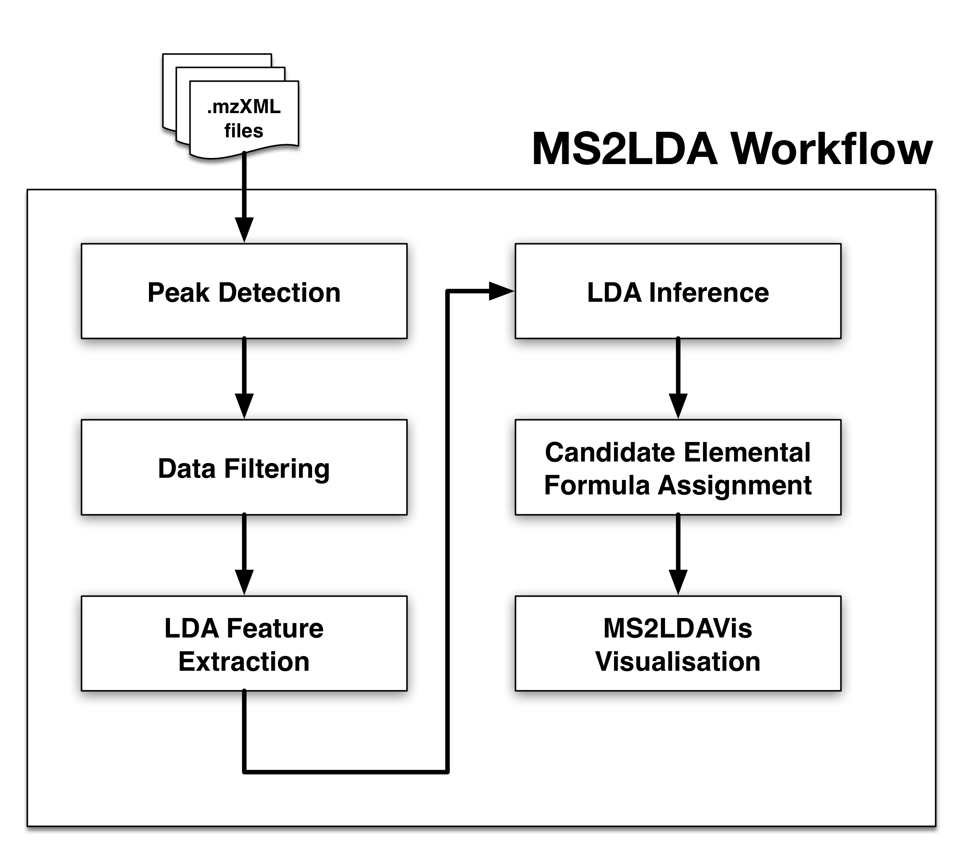

Figure 2: Schematic overview of the MS2LDA workflow.

2.3.1 Data Processing and Transformation

The data conversion stage of MS2LDA is implemented entirely in the ‘R’ programming language, relying on the XCMS package [31] for peak detection and the RMassBank package [32] for detecting MS1-MS2 pairs, before matrix formation by aligning MS2 fragments across different fragmentation spectra. The Mass2Motif discovery stage is implemented in Python and the visualizer [33] in Javascript/D3 on the client (web browser) side. The exploration of Mass2Motifs, however, is not limited through the browser interface alone as the modular nature of the MS2LDA components allows them to be used in constructing different analysis workflows that rely on well-established scientific Python libraries (such as NumPy and SciPy). An example notebook (*example_notebook.ipynb*) demonstrating the data processing and analysis steps performed in this paper is provided in our Github repository (<https://github.com/sdrogers/ms2lda>) and can be adapted for different data processing needs.

In short, for each sample the resulting .mzXML (full scan) files and .mzML (fragmentation) files were used as input to the data conversion stage of the MS2LDA workflow. The outputs of the data conversion stage are R data-frames (matrices) where the columns correspond to MS1 peaks (metabolites) and the rows are the unique fragment or loss features. The entries in the data-frame are the counts of occurrences of each particular fragment or loss feature in the fragmentation spectrum linked to an MS1 peak (see Figure S-1 in the Supporting Information). All data-frames are stored as text files in .CSV (Comma-separated Values) format and can be readily loaded into the next stage of Mass2Motif discovery in the workflow. In addition, m/z, retention time and intensity of all MS1 and MS2 peaks are stored in a two additional .CSV files.

## 2.3.2 Mass2Motif discovery and elemental formula assignment

The resulting .CSV files form the input of the Mass2Motif discovery stage of the workflow, which can be started from the Jupyter notebook environment. LDA was implemented in Python making use of the Numba library [34] that performs just-in-time compilation of Python to native codes for improved performance. A Gibbs sampling scheme was used for LDA inference [35], and details are provided in Supporting Information section 4.2. After the inference and candidate elemental formula assignment steps, the generated objects were serialized into binary (.project) files -- containing results from the entire analysis that can be visualized with the MS2LDAvis environment. Note that once they have been generated, these .project files can be reloaded in the notebook environment to avoid the need for repeated processing on the same input files. We have included an optional elemental formula assignment step (details in Supplementary Information section 4.3 - [36-38]) that can assign candidate elemental formulae to the mass fragments, neutral losses, and precursor ions. This aids in the interpretation of any potentially discovered patterns.

2.3.3 Computational aspects

MS2LDA relies on scripts written in R and Python and is platform-independent (tested on the Windows, Mac, and Linux operating systems.) In principle, MS2LDA is also analytical-platform independent, given that data-dependent fragmentation files containing information-rich spectra can be generated by different analytical platforms. The MS2LDA workflow accepts open data formats, such as MzXML and MzML, as well as fragmentation files in combination with peak lists generated by any peak-picking software tool, e.g. XCMS (used in this study). The scripts developed for the MS2LDA workflow can be easily extended into a web-based application accessible to the general metabolomics public. The entire MS2LDA workflow running on a typical laptop machine (Intel Core i7 3GHz, 8GB RAM) took around 3 hours to process one beer extract data set entirely, with approximately 1.5 hours spent on the data conversion stage and another 1.5 hours on the Mass2Motif discovery stage. More details are available in section 4.5 of the Supporting Information.

## 2.4 Data analysis

The MS2LDAVis module can be used to analyse and explore the discovered Mass2Motifs in the resulting project files (for details, see section 4.4 of the Supporting Information). To aid in visualization and exploration, the distributions over the features that make up the Mass2motifs and the distributions over Mass2motifs for each fragmentation spectrum can be thresholded. The default threshold values were manually selected for visualization but can be varied. In our analysis, Mass2Motifs with degrees ≥10 (i.e. that were present in ten or more spectra after thresholding) were manually inspected and annotated at different levels of confidence (see Table captions of Supporting Tables S-1 and S-2). Annotations of Mass2Motifs were established through expert knowledge and by spectral matching of the MS2 spectra containing the associated fragments and/or neutral losses to the reference spectra in MzCloud ([www.mzcloud.org](http://www.mzcloud.org/)). Key fragment or loss features from the annotated Mass2Motifs in one sample were then searched against the list of Mass2Motifs in other samples and their correspondences established if those key fragment/loss features were present in both.

**3.0 Results**

The MS2LDA workflow was independently applied to four complex biomolecular mixtures in the form of beer extracts. A standard peak-picking metabolomics data processing workflow, based on XCMS and MzMatch [31, 39], was used to match MS1 with MS2 spectra. We obtained, on average (across the four datasets), 1409 and 1125 fragmented MS1 peaks in positive and negative ionization mode respectively (see Supporting Information section 5.1 for more details). These fragmentation pattern were analysed with Latent Dirichlet Allocation (LDA) and the results, i.e. ‘Mass2Motifs’, were explored using the MS2LDAvis environment.

300 Mass2Motifs were extracted for each data file. MS2LDA indeed found recurring mass fragmentation patterns that were checked for biochemical relevance. 30-40 Mass2Motifs in each of the positive ionization mode files were structurally annotated (see Supporting Tables S-1 and S-2). Examples of the biochemically relevant and diverse substructures we found include histidine, phenylalanine, adenine, and a hexose-unit, as well as structural features such as water or carboxyl group loss.

The degree of Mass2Motifs (the number of spectra in which they occurred) varied, with some Mass2Motifs appearing in over 200 spectra (see Supporting Info section 5.2 for more details), demonstrating the ability of MS2LDA to extract both generic and more specific structural features. The number of Mass2Motifs within each spectrum also varied. On average, some 600 spectra in each file consisted of just one Mass2Motif, 300 consisted of two, 50 consisted of three and 20 consisted of four or more. Crucially, across the four files, an average of 70% of the spectra included at least one of the annotated Mass2Motifs (see Supporting Info section 5.2 for more details). This demonstrates the power of MS2LDA for data reduction – annotating just 30-40 of the discovered Mass2Motifs provides valuable insight into the biochemistry of 70% of the spectra. For comparison, we compared the spectra to the MassBank and NIST libraries (see Supplementary Information Section 5.4) and obtained hits for only 39% and 9% of the MS2 spectra at a relatively low matching score threshold (>75% normalized scores) for NIST and MassBank respectively. This drops to 25% and 6% for higher thresholds (>90%). Gaining biochemically relevant insights from 70% of the spectra presents a clear advantage over only extracting insight from 6-25% of spectra. In addition, the methods are not mutually exclusive – we demonstrate that combining MS2LDA with spectral searching can lead to automated Mass2Motif annotation.

**3.1 Automatic, unsupervised, chemical substructure discovery**

The structurally annotated Mass2Motifs cover a diverse set of biochemically relevant structural features, including amino acid related (i.e. histidine, leucine, tryptophan, and tyrosine), nucleotide related (i.e. adenine, cytosine, and xanthine), and other biomolecules such as cinnamic acid, ferulic acid, ribose and N-acetylputrescine. The reproducibility of MS2LDA is demonstrated by the fact that Mass2Motifs related to the same substructure or structural feature were consistently found across two or more beers despite each sample being processed independently (e.g. hexose-related Mass2Motifs were present in all positive ionization mode beer files with degrees from 58 to more than 100 (see Supporting Tables S-1 and S-2)). Differences in degree and absence of some of the Mass2Motifs across the different beer extracts show that variability in metabolic composition are also made visible by MS2LDA.

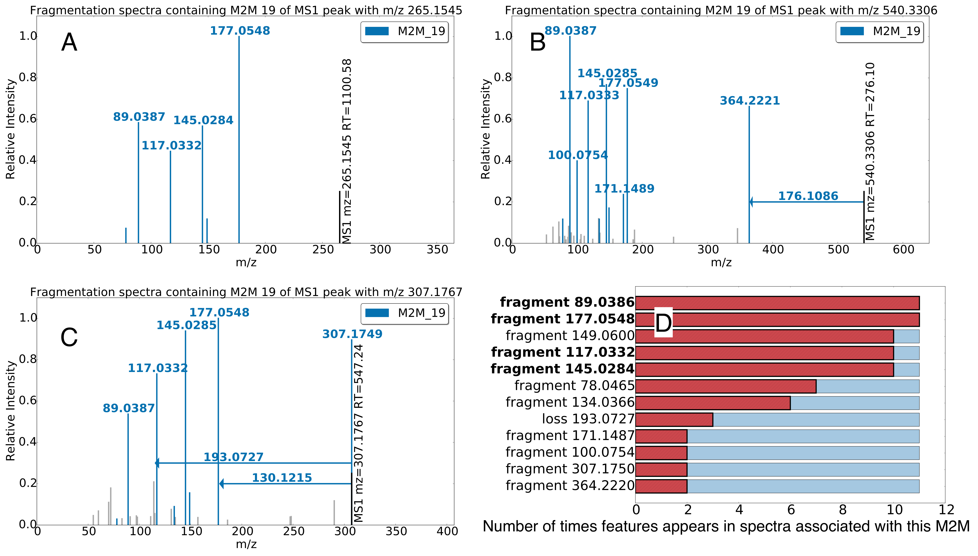A ferulic acid example (a plant-derived hydroxycinnamic acid, present in cereals, one of the ingredients of beer) is visualised in Figure 3. We show three of the 11 spectra that include this Mass2Motif (Mass2Motif 19) with the fragments explained by this Mass2Motif highlighted. Conserved mass fragments are clearly visible across the three spectra and the most conserved are highlighted in the histogram (Figure 3-D). We re-iterate that this method is unsupervised, despite no prior knowledge of fragments of interest being provided (c.f. MS2Analyzer [17]) it is able to extract a biochemically relevant pattern appearing in only 11 of the >1000 spectra. The spectra including this Mass2Motif can be annotated as being ferulic acid related, which is particularly useful for those not identified from spectral similarity (see Section 3.3). Note that the three spectra shown in Figure 3 are somewhat different (compare the small number of fragment peaks in A with the larger number in B) -- there is no guarantee that these molecules would be grouped based on spectral similarity (see Section 3.3).

Figure 3 –Three spectra, each of which is partially explained by Mass2Motif 19, which was annotated as the plant derived ferulic acid substructure. The examples A-C from the beer3 extract positive ionization mode file have mass fragments and neutral losses (arrows originating from the precursor ions) highlighted that are included in M2M_19 (fragments not explained by M2M_19 are shown as light grey). The histogram in D shows how common each fragment / loss is in the 11 instances of M2M_19 found in the dataset. The abundant fragments with an m/z of 177.0545, 145.0284, 117.0332, and 89.0386 Da (highlighted in bold in D) are most consistently present throughout the 11 spectra explained by M2M_19. It is of note that the loss of 176.1086 Da and the fragment of 177.0575 both correspond to the complete ferulic acid substructure.

Positive ionization mode fragmentation spectra are naturally richer than negative mode spectra, providing larger sets of conserved fragments and allowing for more precise structural annotation (see Supporting Tables S-1 and S-2). However, Mass2Motifs indicating the presence of phosphate and sulphate groups (including fragments at 78.9593 ([PO3]-) and 79.9575 ([SO3]-) m/z respectively) were easily identifiable in negative mode. Some Mass2Motifs contained both fragments and losses. In positive mode, we found Mass2Motifs containing the loss of 46.0053 Da ([CHOOH]), as well as m/z fragments at 86.0965 ([C5H12N]+) and 132.1016 ([C6H14NO2]+), indicative of a free carboxylic acid group and a leucine substructure respectively. Interestingly, three positive mode Mass2Motifs pointed to the highly similar aromatic substructures of phenylethene, cinnamic acid (cinnamate), and phenylethyleneamine (i.e., [phenylalanine – CHOOH]), demonstrating that LDA can separate very similar substructures (see Supporting Information section 5.3 for details).

3.2 Matched standards used for validation are well explained by structurally annotated Mass2Motifs

Standard mixtures were run with the beer extracts enabling us to identify molecules from the mixes present in the beer extracts based on co-chromatography and exact mass. As the identity of these molecules is known we can use them to validate our structurally annotated Mass2Motifs. Of the 45 molecules we were able to identify in one or more of the beer extracts, 38 included one or more annotated Mass2Motif.

Figure 4 shows examples selected from the matched standards with fragmentation spectra coloured by Mass2Motif. The spectra for phenylalanine (Figure 4-A) and histidine (Figure 4-B) share Mass2Motif 262, which indicates the presence of a free (underivatized) carboxylic acid group (see Table 1). The loss of CHOOH (Mass2Motif 262) is a common characteristic for those two metabolites and for many other underivatized amino acids and free organic acids and was associated with 10 of the 18 amino acids structures matched from the standards (the remaining 8 have different MS2 spectra due to alternative preferred fragmentation routes – see for example the amine loss in tryptophan, Figure 4-C). The other Mass2Motifs in Figures 4-A and 4-B are indeed related to phenylalanine and histidine, respectively. A key characteristic of MS2LDA is the decomposition of spectra into multiple Mass2Motifs. In each of Figures 4-A to 4-D we observe the spectra being decomposed into two or more Mass2Motifs. We know of no other method that can do this in an unsupervised manner – i.e. without training spectra consisting of known structures or *a priori* knowledge of interesting combinations of fragments and/or losses. All spectra of matched standards can be found within our code repository.

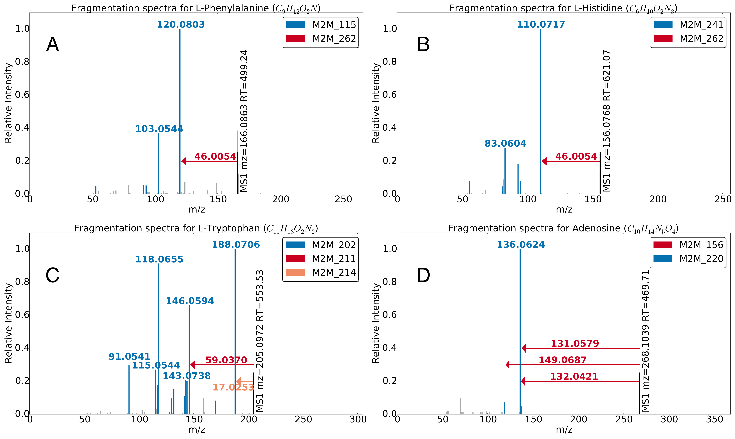

Figure 4 – Multi-coloured Mass2Motif spectra of identified metabolites A) L-histidine, B) L-phenylalanine, C) L-tryptophan, and D) adenosine. Annotated motifs (see Table 1) are indicated in the fragmentation spectra, with coloured mass fragment peaks and coloured arrows for the neutral losses.

|  |  |  |  |  |  |
| --- | --- | --- | --- | --- | --- |
| Mass2Motif (M2M) | Annotation | Degree | | Fragment or Loss Features | Elemental Formula |
| 115 | [phenylalanine-CHOOH]-based substructure. | | 28 | fragment_120.0808,  fragment_103.0546,  fragment_91.0541 | C8H10N,  C8H7,  C7H7 |
| 156 | [ribose (pentose, C5-sugar)-H2O]-related loss. | | 22 | loss_132.0421 | C5H8O4 |
| 202 | [tryptophan-NH3]-related substructure. | | 15 | fragment_118.0654,  fragment_117.0571,  fragment_91.0541,  fragment_130.0645  fragment_188.0706 | C8H8N,  C8H7N,  C7H7,  C9H8N,  C11H10NO2 |
| 211 | N-acetylputrescine substructure. | | 24 | loss_59.0370,  fragment_114.0912,  fragment_72.0447,  fragment_60.0448 | C2H5NO,  C6H12NO,  C3H6NO,  C2H6NO |
| 214 | amine loss. | | 57 | loss_17.0247 | NH3 |
| 220 | adenine substructure. | | 32 | fragment_136.0629,  fragment_119.0351 | C5H6N5,  C5H3N4 |
| 241 | histidine substructure. | | 21 | fragment_110.0718,  fragment_156.0769,  fragment_93.0450,  fragment_95.0608 | C5H8N3,  C6H10N3O2,  C5H5N2,  C5H7N2 |
| 262 | combined loss of H2O and CO – indicative for free carboxylic acid group (COOH). | | 90 | loss_46.0053 | CH2O2 |

Table 1– Annotations of the Mass2Motifs associated to the fragmentation spectra of the standard peaks that are shown in Figure 4. The degree of a Mass2Motif indicates the number of MS2 fragmentation spectra in the beer3 positive ionization mode data having fragment or loss features that can be explained by the Mass2Motif (at the specified thresholding level).

It is noteworthy that multiple Mass2Motifs can explain the same fragment in a single spectrum, i.e. the fragments 110.0718 (C5H8N3, [M+H]+) and 120.0808 (C8H10N, [M+H]+) in Figures 4-A and 4-B are explained by Mass2Motifs 241 and 115 respectively but are also each explained by the 46.0054 loss of Mass2Motif 262. Figure 4-C displays the MS2 spectrum of tryptophan, which is associated with the tryptophan-substructure Mass2Motif 202. The amine loss (17.0235) is the primary small loss associated with tryptophan, which is favoured over the loss of CHOOH for this amino acid. Finally, Figure 4-D is the MS2 spectrum of adenosine, which consists of an adenine molecule conjugated to a ribose sugar molecule. The two associated Mass2Motifs (156, 220) represent these two biochemically relevant structural features (i.e., adenine substructure and a loss corresponding to a ribose sugar), and the fragment 136.0629 (C5H6N5, [M+H]+) is related to both Mass2Motifs. This example clearly demonstrates the manner in which MS2LDA can decompose molecules into their constituent building blocks, which has potential in metabolite annotation (see Section 3.3). Our original annotation of the Mass2Motifs was done without first identifying the standard molecules. It is impressive that of the 38 identified standards that included one or more Mass2Motifs, 32 included structurally relevant Mass2Motifs.

3.3 Mass2Motifs can aid in de novo metabolite annotation

The structurally annotated Mass2Motifs can aid in metabolite annotation. As previously mentioned, on average 70% of the fragmented MS1 features are explained by at least structurally annotated Mass2Motif (see also section 5.2 of the Supporting Information). This suggests that a large percentage of metabolites can be automatically classified according to the presence of substructures and therefore according to function (based on presence of functional groups or as a part of biological pathways).

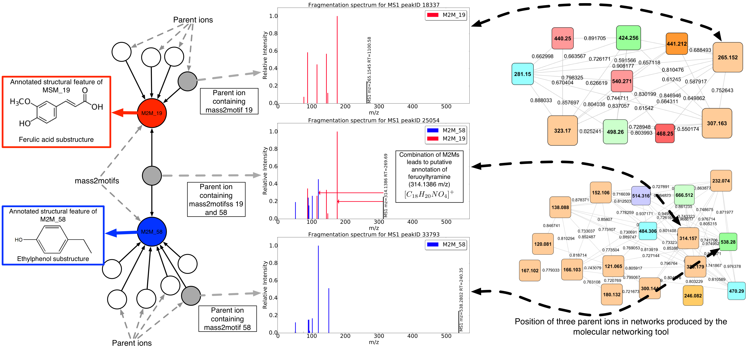To compare with traditional annotation methods, we performed spectral matching using both the NIST MS/MS database for small molecules (http://chemdata.nist.gov/mass-spc/msms-search/) and MassBank [7] (see Section 5.4 in the Supporting Information for details) on the 19 metabolites that we are able to annotate as ferulic acid related based on the presence of the ferulic acid Mass2Motif. 7 could be matched to database spectra, but only 1 of these hits was ferulic acid related (see Supporting Information, Section 5.4). In addition, we can transform the Mass2Motif into a spectrum that itself can be subject to spectral matching, resulting in no ferulic acid-related hits. Similarly, spectra explained by Mass2Motifs related to histidine, tyrosine, and tryptophan were subjected to spectral matching. This is a total of XX spectra that can all be annotated by MS2LDA. Matches to database spectra were found for 33 of these metabolites of which 15 showed hits related to the annotated Mass2Motif substructure, including 7 correct matches. These results demonstrate the additional annotation power provided by MS2LDA. Critically, it does this by matching only small portions of the spectra (substructures) rather than relying on complete spectral matches and can therefore annotate molecules that do not exist in the reference databases. In summary, for this subset of four Mass2Motifs, spectral matching allows classification of 45% of the associated metabolites whereas MS2LDA is able to functionally annotate all of them, i.e. our method is over twice as effective as classical methods in structural annotation of complex metabolomics data. In addition, MS2LDA can annotate and group spectra based on neutral losses (e.g. the loss of a free carboxylic acid group) which is not possible via spectral matching.

Figure 5 –Multi-coloured Mass2Motif MS2 spectra of beer metabolites observed in positive ionization mode. The annotated Mass2Motifs 19 and 58 were found to be representative for ferulic acid and ethylphenol, respectively. In total 11 and 42 MS1 features in the beer3 data set were explained by those two Mass2Motifs respectively. Of those, one was explained by both Mass2Motifs, aiding in its annotation as feruoyltyramine (314.1386 m/z; [C18H20NO4]+). On the right of the plot we show the clusters containing these three MS1 features created using the molecular networking tool [14]. This resulted in clusters of homologous metabolites of positive ionization mode fragmentation files of four beers in one analysis, with the ferulic acid based cluster (top) and tyramine (ethylphenol) based cluster (bottom). The coloring of the nodes is dependent on their presence across the different beer extracts and the node size is proportional to the number of unique beer extracts the node fragmentation spectra are found in. Using this approach, the compound containing both Mass2Motifs has to be forced into one cluster or the other, losing the clear chemical connection with the other substructure.

Spectral clustering approaches (e.g. Molecular Networking [14-16]) can also help in metabolite annotation by propagating identifications through the network. For example, if one spectrum can be identified through spectral matching, its structure can be used to provide putative annotations to its neighbours. MS2LDA differs from this approach in three key ways. Firstly, MS2LDA does not require any complete spectra to be identified (they can be putatively annotated from Mass2Motifs). Secondly, MS2LDA does not require a high degree of total spectral similarity to allow spectra to share annotations; relying only on the presence of a shared Mass2Motif. Finally, spectra can include multiple Mass2Motifs and can therefore be given multiple annotations. Figure 5 shows a subset of the network produced by MS2LDA (a bipartite graph with nodes consisting of Mass2Motifs and parent ions; see Section 3.5) consisting of molecules that include two Mass2Motifs (ferulic acid and ethylphenol). All but one molecule belongs to just one of the Mass2Motifs but one belongs to both (the fragments belonging to each Mass2Motif are clearly visible). The presence of both Mass2Motifs in this molecule allows us to putatively annotate it as feruoyltyramine (314.1386 m/z; [C18H20NO4]+) despite spectral matching producing no relevant hits (see Table S-7 in the Supporting Information, section 5.4). In general, the more Mass2Motifs present in a particular spectrum, the more specific our annotations can become.

The output of Molecular Networking is shown on the right of Figure 5. This produces clusters interpretable as ferulic acid and ethylphenol related. The restriction that each molecule belongs to one cluster results in assignment of the molecule containing both substructures to the ethylphenol cluster. The relationship with ferulic acid is lost and the annotation less specific.

Inspection of other clusters produced by Molecular Networking (see Supporting Information section 5.6 for details) allowed us to identify clusters based on the core structures for histidine, tyrosine and tyramine (ethylphenol), as well as hydroxycinnamic acid, guanine and citric acid, in positive and negative ionization mode respectively. After a more detailed analysis of the Mass2Motifs related to ferulic acid, histidine, tyrosine, and tryptophan, we could annotate ferulic acid conjugates to polyamine structures like putrescine, histidine metabolites conjugated to hexose and organic acid moieties as well as a family of indole (tryptophan) related metabolites (see Supporting Information section 5.4 for more details). Two of those annotated beer metabolites were found to be dipeptides, whereas all others represent amino acids conjugated with other compound classes. Based on the example shown in Figure 7, it is likely that many molecules in these clusters could be better annotated when decomposed into multiple Mass2Motifs rather than being assigned to a single cluster.

3.4 Differential Expression of Mass2Motifs reveals biochemical changes across samples

We have shown that MS2LDA analysis can group molecules according to a shared Mass2Motif. In transcriptomic studies it is common to consider the shared differential expression (DE) of a group of transcripts (that are perhaps transcriptionally related, or share a Gene Ontology classification). Considering transcripts in groups provides greater statistical power and aids in hypothesis development. For a review and comparison of several techniques for analysing the change in groups of transcripts, see [40].

Similarly, by linking the MS2LDA analysis with fold changes of MS1 peaks, we can assess the DE of Mass2Motifs. This allows us to directly assess biochemical changes across groups of samples without having to rely only on those molecules that can be identified via spectral matching. For example, for a pathway-related Mass2Motif, MS2LDA allows us to assess the change in pathway activity directly across groups of samples without first having to identify and map molecules to their respective pathways.

Based on MS1 fold changes between two of the beer extracts (Beer2 and Beer3), we used the PLAGE technique [41] to assess the DE of each Mass2Motif (see Section 5.8 in the Supporting Information for details). In Figure 6 we show heatmaps of the MS1 intensities of molecules associated with four Mass2Motifs that obtained high PLAGE scores. In each case, the change in intensity across the two beer extracts are clear. Figure 6-A shows 7 metabolites including the guanine Mass2Motif. All could be putatively annotated via MS2LDA and two (shown in bold) could be identified with spectral matching. We can observe that in Beer3, the free guanine is present more often, whereas in Beer2, the conjugates of guanine are more abundant. This is a clear example of the kind of hypothesis that can be generated rapidly from the MS2LDA analysis: we are able to perform an unsupervised grouping of metabolites based on the presence of a biochemical substructure (Mass2Motif) and combine this with MS1 information to extract the substructures that appear to be indicative of MS1 intensity changes. We know of no other technique that allows metabolomics fragment data to be analysed in this way. The utility of this approach in, for example, a clinical application is clear. Furthermore, as metabolites can include multiple Mass2Motifs, we observe that 4 annotated guanine related metabolites, i.e., guanosine, two methyl-guanosine isomers, and a pentosyl-hexosylguanine, also contained the pentose loss Mass2Motif, which was also differentially expressed between the two beers. Indeed, the annotated structures of those metabolites all share both a guanine and a pentose substructure.

Within the molecules associated to the pentose Mass2Motif (Figure 6-D) we could annotate all and identify (via spectral matching) 5 pentose containing metabolites, many of which were nucleotide related metabolites. These biochemically relevant metabolites show interesting DE between the two extracts. For comparison, we investigated whether or not these molecules would be grouped with a spectral similarity based clustering approach and discovered that they were actually distributed over 10 spectral clusters. In other words, the interesting structural and intensity similarity between these molecules exposed by MS2LDA would not be found via spectral clustering. Similarly, the 9 tryptophan (indole) related metabolites (many of which are considerably more abundant in Beer 2 than Beer 3) found by MS2LDA (Figure 6-B) were distributed over 7 spectral clusters. Details on all 30 metabolites that were annotated across the four Mass2Motifs discussed here can be found in the supporting information (section 5.8).

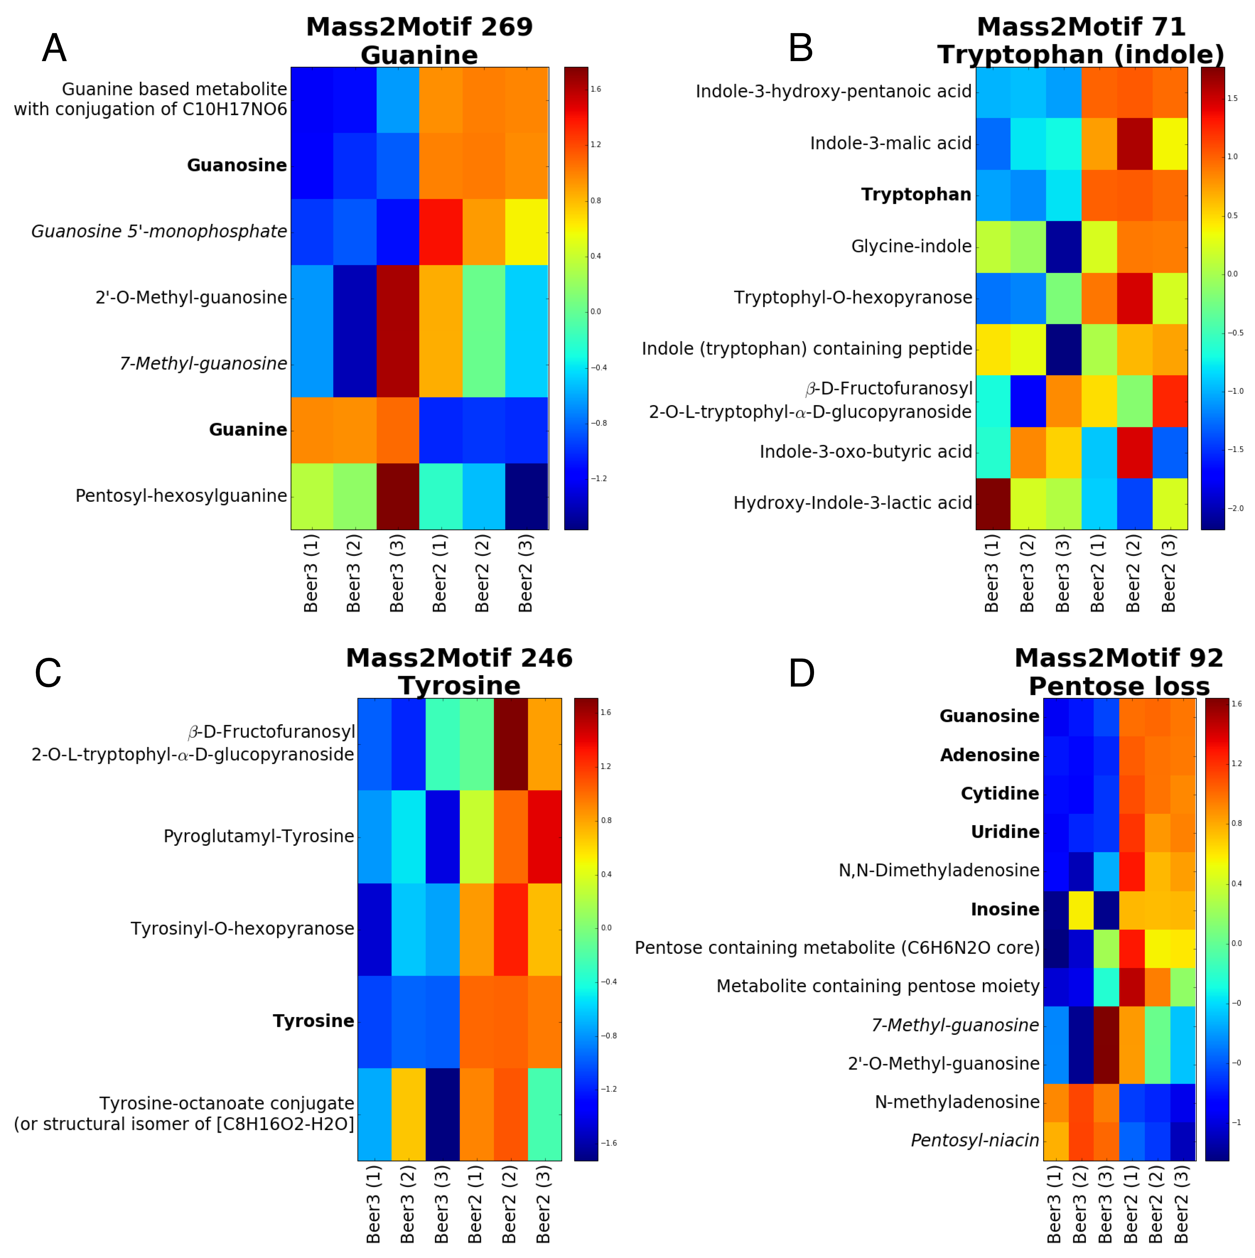We reiterate that the entire analysis is unsupervised, and the discovery of several metabolite groups showing clear differential expression that can be given plausible candidate annotations demonstrates the power of MS2LDA. We also stress that no other method would be able to – in an unsupervised manner – perform analysis based on losses such as the pentose loss highlighted here.

Figure 6: Differential expression heat maps for the A) guanine, B) tryptophan, C) tyrosine and D) pentose loss Mass2Motifs. Each row in the heatmap is an MS1 peak that has been annotated, each column is a sample and entries in the heatmap are the fold changes (natural logarithm-based) coloured according to the indicated scheme. Metabolite identification was performed manually (for the purpose of validation) based on the Metabolite Standard Initiative Metabolite Identification scheme. Bold labels indicate identification at the highest level of confidence (1), while italic labels indicate identification at the next level of confidence (2). The remainder are level (3) or (4).

3.5 MS2LDAvis allows rapid exploration and hypotheses generation

Although MS2LDA reduces the complexity of large fragmentation datasets, the output of is still complex (>1000 precursor ions and ~300 Mass2Motifs). To overcome this, we have developed an interactive visualisation tool that enables rapid exploration of the MS2LDA output.

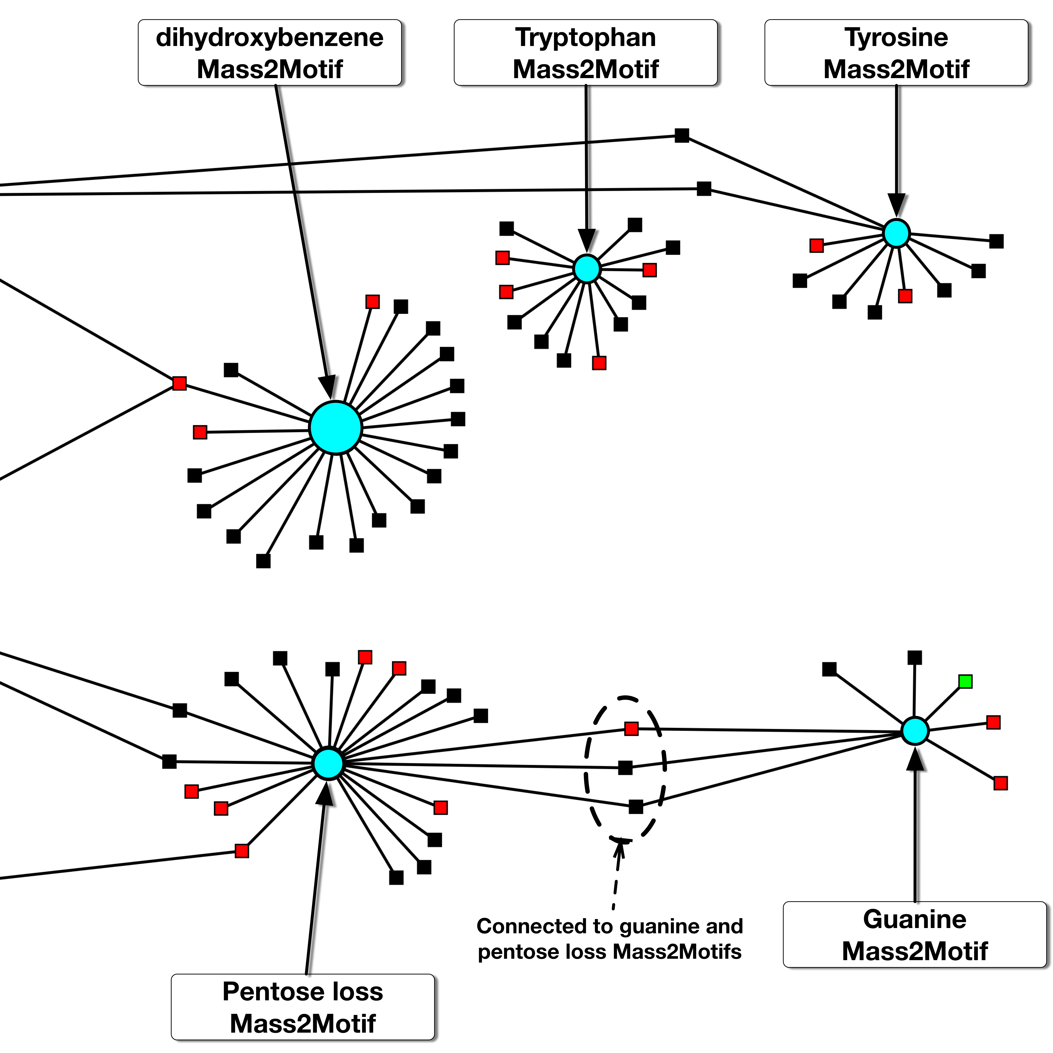

Figure 7 – A subset of the network produced by MS2LDA and displayed by the visualisation tool. The network is a bipartite graph with two sets of nodes, corresponding to the Mass2Motifs (circles) and the parent ions (squares). An edge indicates that a Mass2Motif is found in the spectrum of the parent ion. Parent ions and Mass2Motifs can be sized and coloured according to different characteristics of the data. In this example the parent ions have been coloured according to their fold change between two MS1 datasets of beer extracts (red if >2.72, green if <0.37, black otherwise) and the Mass2Motifs have been sized according to the differential expression score from PLAGE analysis.

The visualisation tool consists of several panels, each of which provides a different view on the MS2LDA output. The first is a network (a subset of which with various Mass2Motifs highlighted is shown in Figure 7). Selection of a Mass2Motif in the network allows the user to view all spectra associated with that Mass2Motif in a separate panel with relevant fragments and neutral losses highlighted (in the style of e.g. Figures 3 and 4). In the final panel, the MS2LDAvis environment shows frequency histograms that can be used to determine how consistently present the conserved fragments or losses are within the Mass2Motif. Examples for histidine related Mass2Motifs found in two of the beer extracts can be seen in Figure 8.

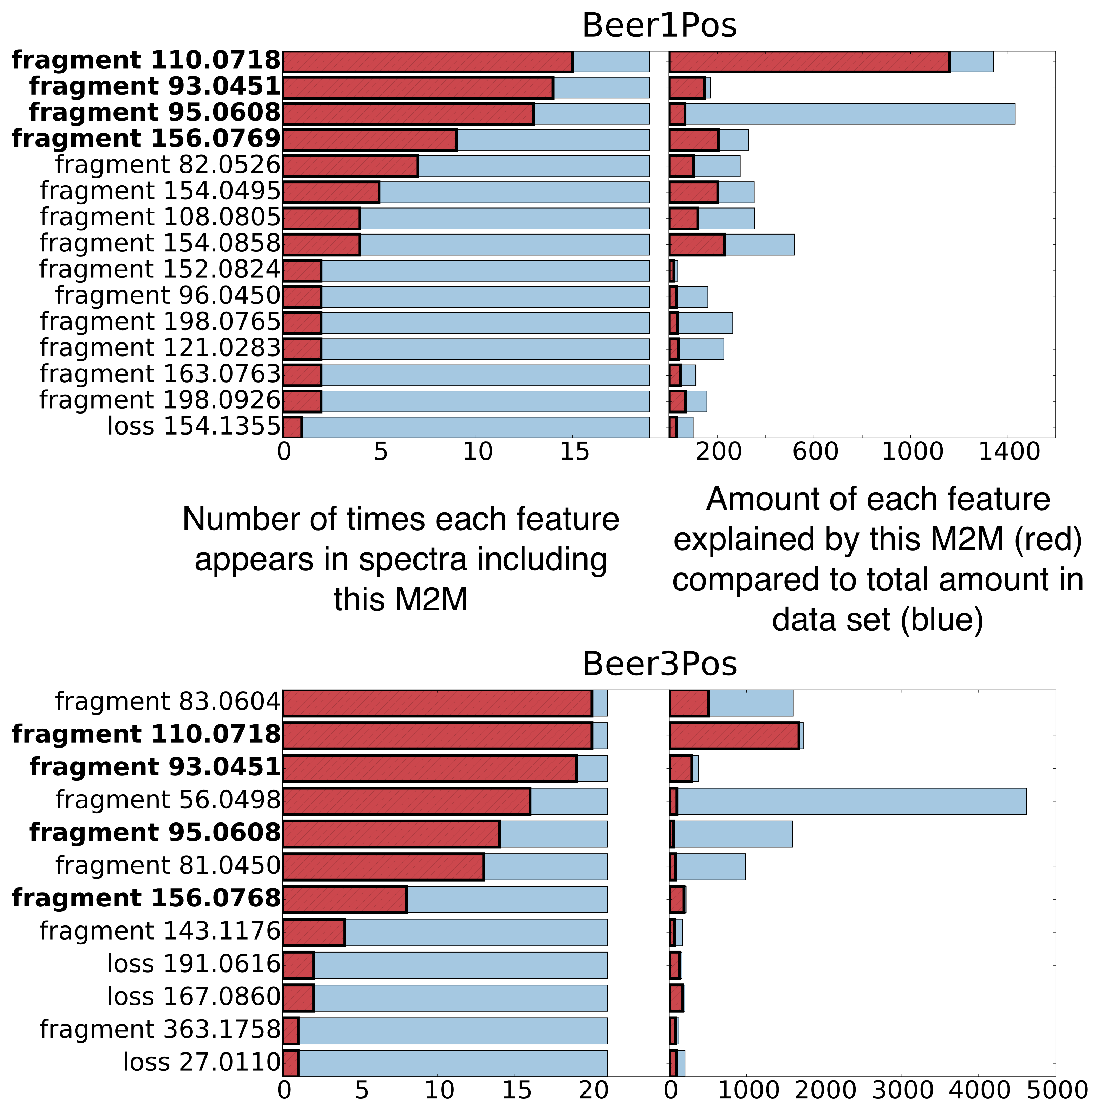

D

B

A

C

Figure 8 – Similar sets of fragment and loss features can be seen in the MS2LDAVis ‘Mass2Motif Feature Frequency’ histograms for histidine-related Mass2Motifs in positive mode of beer1 (top) and beer3 (bottom). The left-hand panels show the number of times each feature appears in spectra associated with this Mass2Motif while the right-hand panel shows the proportion (red) of the total abundance (blue) of this feature within the dataset explained by this Mass2Morif. For example, this Mass2Motif accounts for the vast majority of the total abundance observed for the fragment with mass 110.0718. Conversely, although the fragment with mass 95.0608 appears often in the spectra associated with this Mass2Motif, it appears widely elsewhere too. Because the analyses of the four beers were done separately, fragment masses do not exactly match across samples.

The ‘Mass2Motif Feature Frequencies’ histograms (Figure 8-A, 8-C) display how often particular fragments or losses appear in spectra including this Mass2Motif, indicating their consistency. For example, from Figure 8-A and 8-C we can see that the fragments 110.0718 ([C5H8N3]+) and 93.0450 ([C5H5N2]+) m/z are most consistently present in the histidine Mass2Motifs for Beer 1 and Beer 3. The ‘Mass2Motif Global Frequencies’ histograms (Figure 8-B, 8-D) show how specific these fragments and losses are to this Mass2Motif. The blue bars show the total abundance of each fragment (or loss) in the entire dataset whilst the red bars show the abundance that can be attributed to this Mass2Motif. We see from Figures 8-B and 8-D that globally, most of the observed fragments with m/z 110.0718 ([C5H8N3]+) are explained by these histidine-related Mass2Motifs, whereas although the fragment at m/z 95.0608 is consistently present in these Mass2Motifs it is also abundantly present elsewhere. Had we manually extracted all spectra including m/z 95.0608 we would be faced with a vast number of spectra. By learning the relationships that exist between groups of fragments and losses, MS2LDA is able to provide us with groups of metabolites that are much more likely to be chemically related than spectra or metabolites collected based on the presence of one fragment only. The MS2LDAViz code runs from within the iPython environment and is available in our code repository.

**4. Discussion**

Our motivation for developing MS2LDA came from the idea that conserved fragments and neutral losses can be indicative of substructures shared by multiple molecules, and the parallels we saw between this and LDA analysis of text documents. Our results demonstrate the benefits of this approach to analysis. None of the tools released so far allow for substructure mining in an unsupervised manner from a mass spectrometry based fragmentation data set whilst also allowing for multiple structural features or substructures to be present within one fragmented metabolite. Thus MS2LDA can group molecules that share substructures but do not necessarily have high similarity across their entire MS2 spectra. We show that MS2LDA reduces complex fragmentation data sets into fragmented metabolites explained by one or more patterns of concurring mass fragments or neutral losses -- Mass2Motifs. We were able to manually structurally annotate those Mass2Motifs with biochemically relevant structural features (Supporting Tables S-1 and S-2). The majority of those annotated Mass2Motifs were independently found in several of the beer extracts analysed. Whilst the molecular content of the beers differed slightly, similar metabolites and Mass2Motifs were found to be present in all input files analysed. Thus, MS2LDA not only successfully discovered the conserved mass fragmental patterns present within one fragmented beer extract, but also across different fragmentation files.

As is true for most tools working with mass spectrometry fragmentation data, MS2LDA relies on correct and clean MS1 peak - MS2 spectrum pairs. As a result of the stochastic nature of data-dependent fragmentation and the co-elution of isobaric compounds (molecules with nearly identical m/z values), some MS2 spectra can be contaminated by fragments of other unrelated molecules, and possibly cause incorrect associations between Mass2Motifs and MS1 peaks. As such, MS2LDA works best for complex mixtures where a large number of metabolites (MS1 peaks) are fragmented and information-rich MS2 spectra are produced using for instance, ramped energy or stepped energy (as was used in our study.) Additionally, MS2LDA is suited to high-resolution MS fragmentation, as it can differentiate an increased number of mass fragments and neutral losses, even at low mass range of (50 -70 m/z; see Supporting Information section 5.7).

Whilst the Mass2Motifs resulting from the MS2LDA workflow need to be manually annotated, we found this to be a fairly straightforward task and once this has been performed, the validated structural features or substructures can be propagated onto all connected MS2 spectra. Mass2Motif annotation could be automated and to assess how challenging this might be, we reconstructed the MS2 spectra of 32 fragment-based Mass2Motifs from beer3 (positive mode) and performed spectral matching to the NIST MSMS library (nist_msms) and MassBank. This resulted in 19 Mass2Motifs where the manual annotation was the same or very similar to the best library hit. All results and examples of ‘reconstructed Mass2Motif spectra’ can be found in the Supporting Information section 5.8. These results suggest that automated annotation of conserved patterns is possible and could be integrated into the analysis. To aid exploration of the Mass2Motifs and the induced grouping of molecules, we have developed MS2LDAVis, a visualization environment specifically tailored for the interactive exploration of Mass2Motifs and their associated fragmentation features.

An important step in untargeted mass spectrometry-based metabolomics experiments is the metabolite annotation and identification step. This step has often been the bottleneck in high-throughput metabolomics as only a small number of metabolites can be reliably identified through comparisons to a reference library. We have shown that our proposed MS2LDA workflow can assist the identification step by automatically assigning possible substructures to a fragmented LC-MS peak via the Mass2Motifs present in its MS2 spectrum. MS2LDA can thus quickly classify MS1 peaks into functional relevant classes without necessarily knowing the complete structure of the metabolite. On average, more than 70% of the fragmented metabolites were explained by one or more structurally annotated Mass2Motifs. Compared to a recent beer metabolomics paper where 2-3% of the high-abundant molecular features could be classified, annotated, or identified [11], our results demonstrate that MS2LDA allows us to decipher the complex mixture of metabolites present in a beer extract.

Where MS1 intensity information is available, we have demonstrated that tools previously used mainly for transcriptomic analysis can be used to identify Mass2Motifs that appear to be indicative of intensity variation in metabolites. These can provide biochemical hypotheses as to why the metabolites are changing in expression. For pathway related Mass2Motifs, this is similar to computing the differential expression of metabolites involved in the same metabolic pathway but without first having to identify the metabolites in order to match them to their pathways.

**5. Conclusions**

In this paper, we introduce MS2LDA, a pipeline that simplifies fragmentation data by exploiting the parallels between MS fragmentation data and text documents. The pipeline performs all steps required in the analysis: the preparation of a MS1-MS2 matrix, the LDA analysis, and the graphical visualization of the resulting output. Testing the LDA analysis on beer extracts resulted in numerous informative patterns of concurrent mass fragmental and neutral loss, termed Mass2Motifs, which we could annotate with diverse biochemical relevant core structures. This approach is markedly different from other recently released advanced spectral analysis tools as it allows for multiple Mass2Motifs to be associated with one metabolite, and also facilitates quick unsupervised determination of the key mass fragments or neutral losses that are part of a conserved structural motif.

MS2LDA is unsupervised and platform-independent (both in the computational and analytical sense) and therefore useful for a wide area of biological applications such as clinical metabolomics, natural products research, and toxicological applications. Our proposed focus on pattern mining on the MS2 fragmentation data alone to aid in identification of functional classes of metabolites is novel and is complementary to the common usage of fragmentation data to identify individual metabolites via one-by-one comparisons to spectral databases. In the near future, we see great potential in developing a larger library of validated Mass2Motifs from data sets produced on a diverse range of analytical platforms and different sample types. We are also planning to explore the extension of the basic LDA model used in MS2LDA to handle Mass2Motif inference from multiple data sets. Prior information on which candidate Mass2Motifs an MS2 spectrum might include could also be incorporated into the MS2LDA workflow, resulting in a semi-supervised model. Other LDA-based techniques developed for text (e.g. hierarchical LDA [REF]) are also likely to offer benefits in this domain. We anticipate that MS2LDA to be particularly useful in research areas such as pharmacometabolomics, environmental analysis, and nutritional metabolomics, as it can quickly and in an unsupervised manner recognize substructure patterns related to drugs, pollutants, and food-derived molecules, respectively. Furthermore, when linked with fold changes from MS1 data, allows the researcher to focus on clusters of metabolites that share expression changes and a chemical substructure.

**6. Acknowledgements:**

The authors thank Dr. Emma Schymanski, Dr. Tony Larson, and Dr. Samuel Bertrandt for their helpful scientific discussions and assistance with implementation of R scripts from: RMassBank (ES), xcmsFragments (TL), and the 7 golden rules (SB). The authors thank Dr. Niels van den Broek for helpful discussions on acquisition of mass fragmentation spectra. JJJvdH was supported by the Wellcome Trust [grant no. 105614/Z/14/Z]. MPB was funded as part of the Wellcome Trust core grant to the Wellcome Trust Centre for Molecular Parasitology (085349). JW was supported by a SICSA PhD studentship. SR was supported by BBSRC [grant no. BB/L018616/1].

**Supporting Information:**

Supporting Information is available with this manuscript – the following files can be found online:

Supporting Table S-1 (word document) - Table with Mass2Motifs (MSMs) discover in the four positive ionization mode fragmentation files of the beer extracts

Supporting Table S-2 (word document) - Table with Mass2Motifs (MSMs) discover in the four negative ionization mode fragmentation files of the beer extracts

Supporting Material containing Supporting Sections 1 – 5 (word document)

Cytoscape session files for Molecular Networking results of beer extracts in positive and negative ionization modes.

We plan to submit the data to Metabolights repository and to make the molecular networking results publically available on the website as well.

**References**

1. van der Hooft, J.J.J., et al., *Structural elucidation of low abundant metabolites in complex sample matrices.* Metabolomics, 2013. **9**(5): p. 1009-1018.

2. Kind, T. and O. Fiehn, *Metabolomic database annotations via query of elemental compositions: Mass accuracy is insufficient even at less than 1 ppm.* Bmc Bioinformatics, 2006. **7**: p. -.

3. Misra, B.B. and J.J.J. van der Hooft, *Updates in metabolomics tools and resources: 2014–2015.* ELECTROPHORESIS, 2016. **37**(1): p. 86-110.

4. Hufsky, F., K. Scheubert, and S. Böcker, *Computational mass spectrometry for small-molecule fragmentation.* TrAC Trends in Analytical Chemistry, 2014. **53**(0): p. 41-48.

5. Dührkop, K., et al., *Searching molecular structure databases with tandem mass spectra using CSI:FingerID.* Proceedings of the National Academy of Sciences, 2015. **112**(41): p. 12580-12585.

6. Ridder, L., et al., *Automatic Chemical Structure Annotation of an LC–MSn Based Metabolic Profile from Green Tea.* Anal. Chem., 2013. **85**(12): p. 6033-6040.

7. Horai, H., et al., *MassBank: A public repository for sharing mass spectral data for life sciences.* Journal of Mass Spectrometry, 2010. **45**(7): p. 703-714.

8. Wishart, D.S., et al., *HMDB 3.0—The Human Metabolome Database in 2013.* Nucleic Acids Res., 2013. **41**(D1): p. D801-D807.

9. Jeffryes, J., et al., *MINEs: open access databases of computationally predicted enzyme promiscuity products for untargeted metabolomics.* Journal of Cheminformatics, 2015. **7**(1): p. 1-8.

10. Ridder, L., et al., *In Silico Prediction and Automatic LC–MSn Annotation of Green Tea Metabolites in Urine.* Analytical Chemistry, 2014. **86**(10): p. 4767-4774.

11. Allen, F., R. Greiner, and D. Wishart, *Competitive fragmentation modeling of ESI-MS/MS spectra for putative metabolite identification.* Metabolomics, 2015. **11**(1): p. 98-110.

12. Blei, D.M., A.Y. Ng, and M.I. Jordan, *Latent dirichlet allocation.* J. Mach. Learn. Res., 2003. **3**: p. 993-1022.

13. Garg, N., et al., *Mass spectral similarity for untargeted metabolomics data analysis of complex mixtures.* International Journal of Mass Spectrometry, 2015. **377**: p. 719-727.

14. Yang, J.Y., et al., *Molecular Networking as a Dereplication Strategy.* Journal of Natural Products, 2013. **76**(9): p. 1686-1699.

15. Watrous, J., et al., *Mass spectral molecular networking of living microbial colonies.* Proceedings of the National Academy of Sciences, 2012. **109**(26): p. E1743–E1752.

16. Nguyen, D.D., et al., *MS/MS networking guided analysis of molecule and gene cluster families.* Proceedings of the National Academy of Sciences, 2013. **110**(28): p. E2611-E2620.

17. Ma, Y., et al., *MS2Analyzer: A Software for Small Molecule Substructure Annotations from Accurate Tandem Mass Spectra.* Analytical Chemistry, 2014. **86**(21): p. 10724-10731.

18. Daly, R., et al., *MetAssign: Probabilistic annotation of metabolites from LC–MS data using a Bayesian clustering approach.* Bioinformatics, 2014.

19. Tsai, T.-H., et al., *Profile-Based LC-MS Data Alignment--A Bayesian Approach.* IEEE/ACM Trans. Comput. Biol. Bioinformatics, 2013. **10**(2): p. 494-503.

20. Shen, H., et al., *Metabolite identification through multiple kernel learning on fragmentation trees.* Bioinformatics, 2014. **30**(12): p. i157-i164.

21. Woldegebriel, M. and G. Vivó-Truyols, *Probabilistic Model for Untargeted Peak Detection in LC–MS Using Bayesian Statistics.* Analytical Chemistry, 2015.

22. Wiczling, P., Ł. Kubik, and R. Kaliszan, *Maximum A Posteriori Bayesian Estimation of Chromatographic Parameters by Limited Number of Experiments.* Analytical Chemistry, 2015. **87**(14): p. 7241-7249.

23. Xin, C., et al. *Probabilistic topic modeling for genomic data interpretation*. in *Bioinformatics and Biomedicine (BIBM), 2010 IEEE International Conference on*. 2010.

24. Zhang, R., et al., *Exploiting topic modeling to boost metagenomic reads binning.* BMC Bioinformatics, 2015. **16**(Suppl 5): p. S2.

25. Rogers, S., et al., *The latent process decomposition of cDNA microarray data sets.* Computational Biology and Bioinformatics, IEEE/ACM Transactions on, 2005. **2**(2): p. 143-156.

26. Liu, B., et al., *Identifying functional miRNA–mRNA regulatory modules with correspondence latent dirichlet allocation.* Bioinformatics, 2010. **26**(24): p. 3105-3111.

27. Sweeney, D.L., *A Data Structure for Rapid Mass Spectral Searching.* Mass Spectrometry, 2014. **3**(Special_Issue_2): p. S0035-S0035.

28. Scott, D.R., *Pattern recognition/expert system for identification of toxic compounds from low resolution mass spectra.* Chemometrics and Intelligent Laboratory Systems, 1994. **23**(2): p. 351-364.

29. Hummel, J., et al., *Decision tree supported substructure prediction of metabolites from GC-MS profiles.* Metabolomics, 2010. **6**(2): p. 322-333.

30. Creek, D.J., et al., *Toward Global Metabolomics Analysis with Hydrophilic Interaction Liquid Chromatography–Mass Spectrometry: Improved Metabolite Identification by Retention Time Prediction.* Analytical Chemistry, 2011. **83**(22): p. 8703-8710.

31. Smith, C.A., et al., *XCMS:  Processing Mass Spectrometry Data for Metabolite Profiling Using Nonlinear Peak Alignment, Matching, and Identification.* Analytical Chemistry, 2006. **78**(3): p. 779-787.

32. Stravs, M.A., et al., *Automatic recalibration and processing of tandem mass spectra using formula annotation.* Journal of Mass Spectrometry, 2013. **48**(1): p. 89-99.

33. Sievert, C. and K.E. Shirley, *LDAvis: A method for visualizing and interpreting topics.* Proceedings of the Workshop on Interactive Language Learning, Visualization, and Interfaces, 2014: p. 63-70.

34. Oliphant, T., *Numba python bytecode to LLVM translator.* Proceedings of the Python for Scientific Computing Conference (SciPy), 2012.

35. Griffiths, T.L. and M. Steyvers, *Finding scientific topics.* Proceedings of the National Academy of Sciences, 2004. **101**(suppl 1): p. 5228-5235.

36. Kind, T. and O. Fiehn, *Seven Golden Rules for heuristic filtering of molecular formulas obtained by accurate mass spectrometry.* Bmc Bioinf., 2007. **8**: p. art. no. 105.

37. Bocker, S. and Z. Liptak, *A Fast and Simple Algorithm for the Money Changing Problem.* Algorithmica, 2007. **48**(4): p. 413-432.

38. Böcker, S., et al., *SIRIUS: decomposing isotope patterns for metabolite identification.* Bioinformatics, 2009. **25**(2): p. 218-224.

39. Scheltema, R.A., et al., *PeakML/mzMatch: A File Format, Java Library, R Library, and Tool-Chain for Mass Spectrometry Data Analysis.* Analytical Chemistry, 2011. **83**(7): p. 2786-2793.

40. Tarca, A.L., G. Bhatti, and R. Romero, *A Comparison of Gene Set Analysis Methods in Terms of Sensitivity, Prioritization and Specificity.* PLoS ONE, 2013. **8**(11): p. e79217.

41. Tomfohr, J., J. Lu, and T.B. Kepler, *Pathway level analysis of gene expression using singular value decomposition.* BMC Bioinformatics, 2005. **6**(1): p. 1-11.